**CEE 526 Finite Elements for Engineers**

**Modeling Project 1-3**

Due Date: April 6th , 2016

Author: Michael Justice

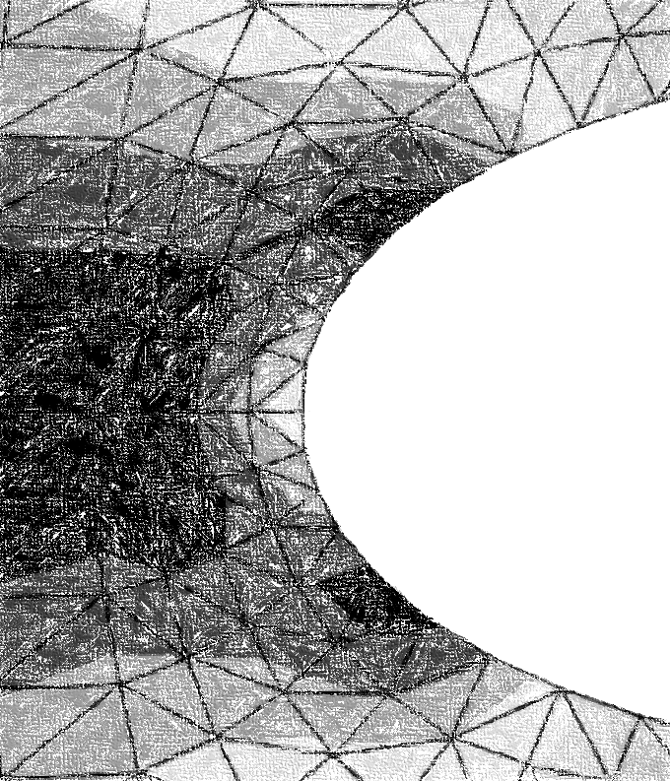

Table of Contents

Glass Syringe 4

Problem Description 4

Finite Element Model 5

Results (and Convergence Results) 5

Conclusions 9

References 10

Half-Symmetric Concrete Culvert 11

Problem Description 11

Finite Element Model 12

Results (and Convergence Results) 13

Conclusions 16

References 17

List of Figures

Figure 1 – (Syringe ) Problem Figure 4

Figure 2 - (Syringe ) Model with Shown Boundary Conditions 5

Figure 3a – (Syringe ) Deformed Shape Using Q4 Elements 6

Figure 3b - (Syringe ) Deformed Shape Using T3 Elements 7

Figure 4 – (Syringe ) Stress Convergence of Q4, T3 Elements 8

Figure 5 - (Syringe ) Displacement Convergence of Q4, T3 Elements 9

Figure 6 - (Culvert) Problem Figure 11

Figure 7- (Culvert) Model with Shown Boundary Conditions 13

Figure 8a – (Culvert) Deformed Shape Using Q4 Elements 13

Figure 8b -(Culvert) Deformed Shape Using T3 Elements 14

Figure 9– (Culvert) Stress Convergence of Q4, T3 Elements 15

Figure 10 -– (Culvert) Displacement Convergence of Q4, T3 Elements 16

List of Equations

**No table of Equations entries found.**

List of Tables

Table 1 – (Syringe ) Q4 Mesh Summary 7

Table 2– (Syringe ) T3 Mesh Summary 8

Table 3 - (Culvert) Q4 Mesh Summary 14

Table 4-(Culvert) T3 Mesh Summary 15

# Glass Syringe

## Problem Description

For this FEA (Finite Element Analysis) project, the goal was to a) determine the maximum principle stress in a glass syringe with an applied 50N load (over the plunger) and the respected maximum displacement, and b) compare the maximum principle stress with the ultimate tensile strength of glass. These two tasks were accomplished using the FEA program Abaqus. The free (student) version of the program was used for this project. Figure 1 below is a sketch of the glass syringe.

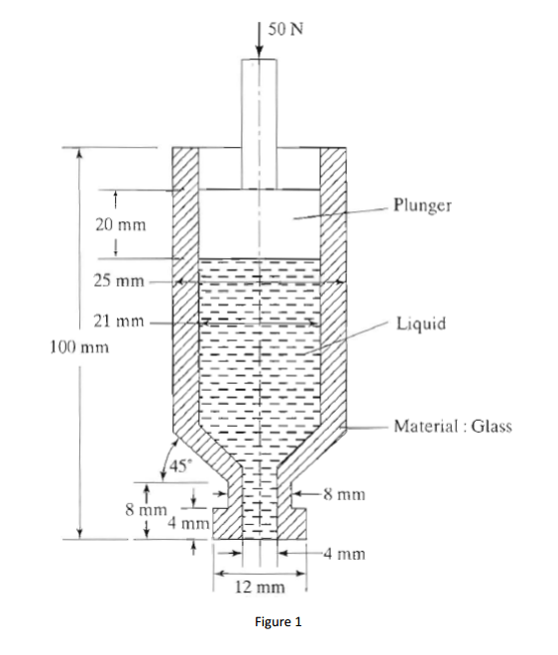

r +

z+

|  |
| --- |
| Figure 1 – (Syringe) Problem Figure |

The model is a glass syringe with an overall dimension of 100 mm, with an applied vertical load of 50 N. The glass syringe was filled with liquid (a density of approximately 1060 kg/m^3, similar to that of human blood). The bottom outlet was assumed to be closed to perform the analysis. The ultimate tensile strength of glass was determined to be 70e6 Pa[1].

## Finite Element Model

The finite element model (FEM) was constructed using the student version of Abaqus. The limitation of the student version is that all models are limited to 1000 nodes or less. Therefore, only *linear* Q4 and T3 elements were used to stay under the 1000 node limit. These two element types alone were also chosen to ensure a proper systematic approach to yield an accurate result for the convergence analysis.

The model was created on the basis that the syringe has an elastic (linear), isotropic material with an elastic modulus and Poisson’s ratio of 50e9 Pa and 0.22, respectively. The model was assumed to be of axisymmetric stress, since the model was found to be symmetric about the vertical axis. Because of the assumption of axisymmetric stress, there is only shear stress in the r-z plane. Normal stress is found only in the r and z directions, with the addition of hoop stress. For axisymmetric problems, the entire FE model is a function of r and z (the radial and axial direction, respectively). With these stresses come the strains in the same directions/orientations. Below is a model (Figure 2) of the syringe with the uniform loading due to the applied pressure on the liquid within.

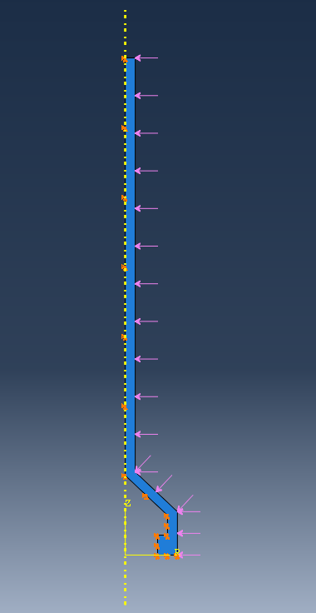

**Uniform Loading**

**Pinned Condition**

Figure 2 - (Syringe ) Model with Shown Boundary Conditions

The loading was applied normally to the surface to simulate the pressure of the liquid. The boundary (or fixity) conditions were such that the glass syringe was pinned in the r-z directions, as shown above in Figure 2.

## Results (and Convergence Results)

The following figure is the deformed shape of the model with Q4 elements (Figure 3).

`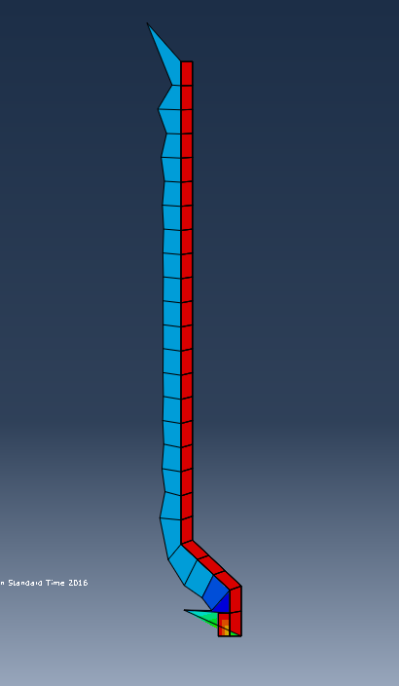

|  |
| --- |
| Figure 3a – (Syringe) Deformed Shape Using Q4 Elements |

Note that higher principle stresses were encountered at the bottom of the syringe, which was expected. The deformed shape is clearly wrong, which could possibly be due to the application of the “pinned” boundary conditions around the edges of the model near the applied uniform load (stress singularity). The following figure (Figure 3b) illustrates the deformed shape of the syringe with T3 elements.

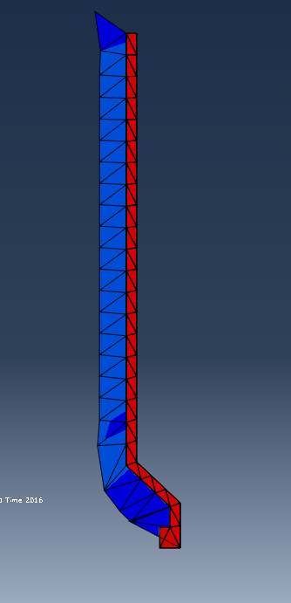

|  |
| --- |
|  |

Figure 3b - (Syringe) Deformed Shape Using T3 Elements

Below is Table 1, which summarizes the finite element result for the Q4 model.

Table 1 – (Syringe) Q4 Mesh Summary

|  |  |  |  |  |
| --- | --- | --- | --- | --- |
| **Model** | **Element Type** | **Number of Elements** | **Max Principle Stress (ABS) (Pa)** | **Max Displacement (mm)** |
| Model 1 | Q4 | 26 | 69994 | 0.0663 |
| Model 2 | Q4 | 52 | 71113 | 0.0888 |
| Model 3 | Q4 | 104 | 72399 | 0.0944 |
| Model 4 | Q4 | 208 | 73674 | 0.1034 |
| Model 5 | Q4 | 416 | 74265 | 0.1933 |

From Table 1, it can be seen that the max principle stress continues to increase with no apparent convergence. Again, this is most likely due to the incorrect application of the boundary condition. Below is Table 2, which summarizes the finite element result for the T3 model.

Table 2– (Syringe) T3 Mesh Summary

|  |  |  |  |  |
| --- | --- | --- | --- | --- |
| **Model** | **Element Type** | **Number of Elements** | **Max Principle Stress (ABS) (Pa)** | **Max Displacement (mm)** |
| Model 1 | T3 | 52 | 71332 | 0.0541 |
| Model 2 | T3 | 104 | 72313 | 0.0789 |
| Model 3 | T3 | 208 | 73842 | 0.0832 |
| Model 4 | T3 | 416 | 74296 | 0.1009 |
| Model 5 | T3 | 832 | 75571 | 0.1933 |

From Table 2, it can again be seen that the principle stresses do not converge. Figure 4 below illustrates this non-convergence and compares the two element types.

|  |
| --- |
| Figure 4 – (Syringe) Stress Convergence of Q4, T3 Elements |

From Figure 4, it can be seen that T3 elements have higher stresses than Q4, though neither generally converge. Plotting displacements, it can be seen here that displacements display a non-converging trend as well (Figure 5).

Figure 5 - (Syringe ) Displacement Convergence of Q4, T3 Elements

Comparing the max principle stress to that of the ultimate tensile strength of glass, we find the following:

Table 3– (Syringe) Ultimate Tensile Strength Comparison

|  |  |  |
| --- | --- | --- |
|  | **Ultimate Tensile Strength** | **Max Principle Stress** |
| Stress: | 70e6 Pa | 75e3 Pa |

The maximum principle stress is 3 orders of magnitude less than the ultimate tensile strength. Though the max principle stress is less than the ultimate, it is clear there was some fault with the FE model, and as such these values cannot be relied upon.

## Conclusions

The following observations from the above results can be made about the finite element analysis of the glass syringe:

1. Stress singularity will occur if loads are placed at the exact location of a boundary condition.
2. Displacements (and therefore stresses) will vary largely between elements when stress singularity is present.
3. Displacements (and therefore stresses) will not converge if stress singularity is present.
4. Maximum Principle Stress (ABS) = 75e3 Pa

## References

1. Lehman, Richard. *Mechanical Properties of Glass*. London: Wiley-ISTE, 2015. *Glassproperties.com*. Web. 6 Apr. 2016.

# Half-Symmetric Concrete Culvert

## Problem Description

For this FEA (Finite Element Analysis) project, the goal was to a) determine the largest and smallest principle stress and b) the location of the largest and smallest principle stress. These two tasks were accomplished using the FEA program Abaqus. The free (student) version of the program was used for this project. Figure 6 below is a sketch of the concrete culvert.

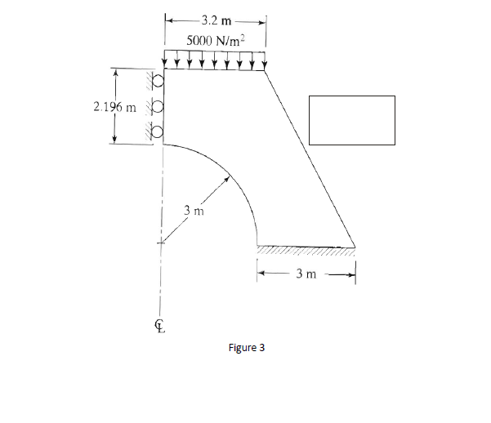

X +

Y+

|  |
| --- |
|  |

Figure 6 - (Culvert) Problem Figure

The model is a half-symmetric concrete culvert with a 3m radius culvert and an applied vertical line load of 5000 N/m (unit thickness of 1m). The elastic modulus of the concrete is 32e9 Pa with a Poisson’s ratio of 0.15.

## Finite Element Model

The finite element model (FEM) was constructed using the student version of Abaqus. The limitation of the student version is that all models are limited to 1000 nodes or less. Therefore, only *linear* Q4 and T3 elements were used to stay under the 1000 node limit. These two element types alone were also chosen to ensure a proper systematic approach to yield an accurate result for the convergence analysis.

The model was created on the basis that the concrete culvert has elastic (linear), isotropic material with an elastic modulus and Poisson’s ratio as mentioned previously. The model was assumed to be of plane-strain, since the thickness of the culvert is assumed to be infinitely longer than the planar dimensions, and that the loading is only in the X-Y Plane. Because of the assumption of plane strain, there is no shear strain in the X-Z or Y-Z plane. Since there is no applied loading in the Z-direction (which constitutes the application of plane-strain), there is no strain in the Z-direction. In order to simplify the model, half of the concrete culvert was used in the analysis (symmetry). Figure 7 below illustrates the loading and fixity conditions of the model.

`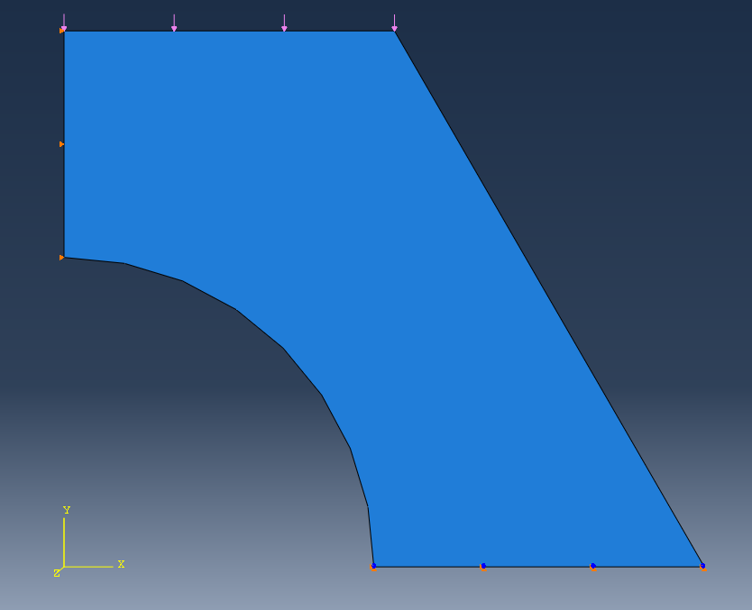

**5000 N/m Line Load**

**Fixed Condition**

**Roller Condition**

Figure 7- (Culvert) Model with Shown Boundary Conditions

The loading was applied at the top side of the culvert. The boundary (or fixity) conditions were such that the model was fixed along the bottom edge and a roller support applied along the vertical edge on the left (see Figure 7).

## Results (and Convergence Results)

Applying the uniform load of 5000 N/m at the top side of the half culvert, the following deformed shape was generated (Figure 8a). Note the locations of the smallest and largest principle stresses!

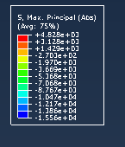 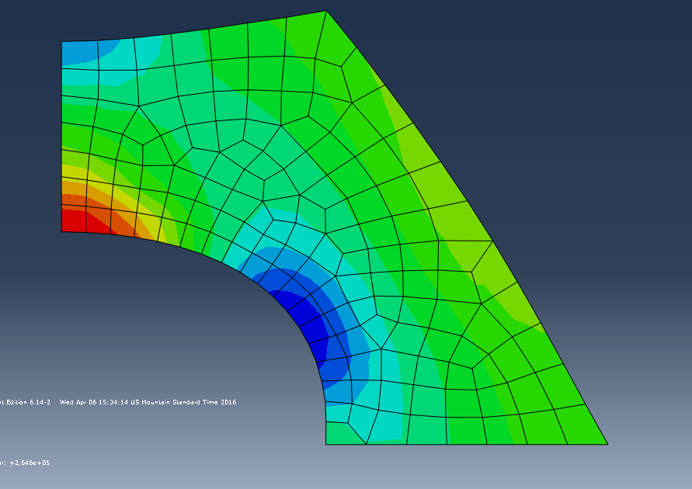

**Smallest Principle Stress**

**Largest Principle Stress**

|  |
| --- |
|  |

Figure 8a – (Culvert) Deformed Shape Using Q4 Elements

The maximum (or largest) principle stress is located as shown above, in the center of the half-symmetric culvert opening. This is due to stress concentrations at the opening, which is a phenomenon of fracture mechanics. This is the same realization made as in the steel plate with a circular hole (see MP1-1). The smallest principle stress was located to the top of the culvert opening.

The following figure (Figure 8b) illustrates the deformed shape of the culvert with T3 elements.

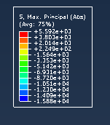 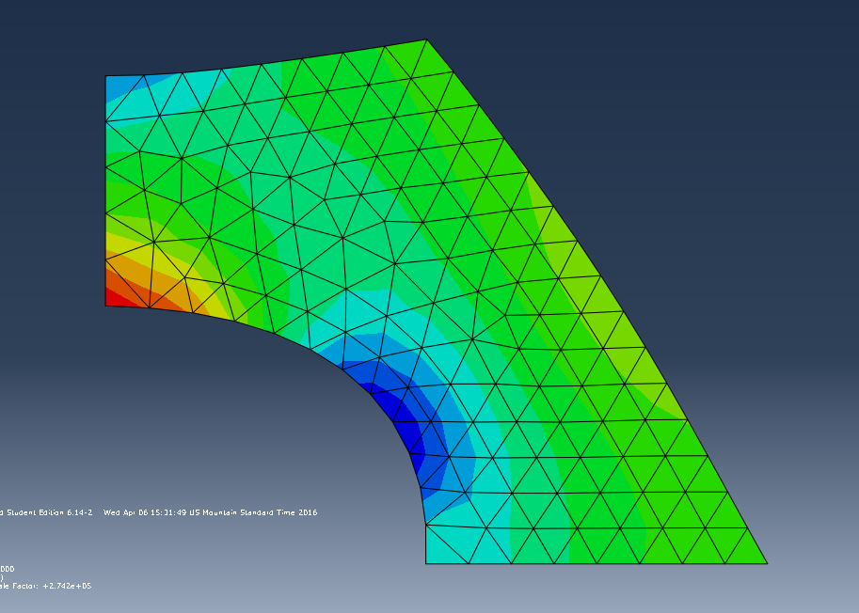

|  |
| --- |
|  |

Figure 8b -(Culvert) Deformed Shape Using T3 Elements

The stress table to the left of Figure 8a, 8b is the principle stress color legend for the model. Below is Table 4, which summarizes the finite element result for the Q4 model.

Table 4 - (Culvert) Q4 Mesh Summary

|  |  |  |  |  |  |
| --- | --- | --- | --- | --- | --- |
| **Model** | **Element Type** | **Number of Elements** | **Max Principle Stress (kPa)** | **Min Principle Stress (kPa)** | **Max Displacement (m)** |
| Model 1 | Q4 | 21 | 12.56 | 2.362 | 2.339e-6 |
| Model 2 | Q4 | 46 | 14.59 | 3.150 | 2.339e-6 |
| Model 3 | Q4 | 143 | 14.74 | 4.828 | 2.343e-6 |
| Model 4 | Q4 | 254 | 15.56 | 5.395 | 2.349e-6 |
| Model 5 | Q4 | 587 | 16.58 | 6.110 | 2.357e-6 |

From Table 3, it can be seen that the principle stresses converge from below, which is expected. Below is Table 5, which summarizes the finite element result for the T3 model.

Table 5-(Culvert) T3 Mesh Summary

|  |  |  |  |  |  |
| --- | --- | --- | --- | --- | --- |
| **Model** | **Element Type** | **Number of Elements** | **Max Principle Stress (kPa)** | **Min Principle Stress (kPa)** | **Max Displacement (m)** |
| Model 1 | T3 | 42 | 12.43 | 0.064 | 2.040e-6 |
| Model 2 | T3 | 89 | 14.51 | 3.260 | 2.165e-6 |
| Model 3 | T3 | 234 | 14.93 | 5.592 | 2.261e-6 |
| Model 4 | T3 | 437 | 15.88 | 6.306 | 2.295e-6 |
| Model 5 | T3 | 977 | 16.46 | 6.972 | 2.318e-6 |

From Table 5, it can again be seen that the principle stress converges from below. Figure 9 below illustrates this convergence and compares the two element types.

Figure 9– (Culvert) Stress Convergence of Q4, T3 Elements

|  |
| --- |
|  |

From Figure 9, it can be seen that T3 elements converge faster than Q4 elements, due to the fact that a model with the T3 element type will have twice as many elements than that of the same model with the Q4 element type. Plotting displacements, it can be seen that displacements generally converge faster than stresses. This is because stresses are derivatives of displacements, and therefore error will compound. Figure 10 illustrates the converging trend of the max displacements in the syringe .

Figure 10 -– (Culvert) Displacement Convergence of Q4, T3 Elements

## Conclusions

The following observations from the above results can be made about the finite element analysis of the culvert:

1. T3 elements converge faster than Q4 elements, or in other words, higher-order elements converge faster than lower-order elements.
2. Stresses converge from below.
3. Displacements converge faster than stresses.
4. The maximum principle stress occurs at the opening in the middle of the half-symmetric culvert.
5. The minimum principle stress occurs at the top of the culvert opening.

## References